**AIR QUALITY MONITORING IN CAMPUS WITH TIME SERIES BASED DATA VISUALIZATION DASHBOARD**

**A PROJECT REPORT**

Submitted by

**ALAN JOB TOC18CS003**

**ANTONY SHON K. J TOC18CS008**

**ELDO GEORGE TOC18CS020**

**JAYASANKAR A. V TOC18CS023**

**to**

**APJ ABDUL KALAM TECHNOLOGICAL UNIVERSITY**

in partial fulfillment of the requirements for the award of the degree

of

**Bachelor of Technology**

in

**COMPUTER SCIENCE AND ENGINEERING**



**JUNE 2022**

**DEPARTMENT OF COMPUTER SCIENCE AND ENGINEERING**

**Toc H INSTITUTE OF SCIENCE & TECHNOLOGY**

**Arakkunnam P.O, Ernakulam District, Kerala – 682 313**

**Toc H INSTITUTE OF SCIENCE & TECHNOLOGY**

**Arakkunnam PO, Ernakulam District, Kerala – 682 313**



**DEPARTMENT OF**

**COMPUTER SCIENCE AND ENGINEERING**

**CERTIFICATE**

## This is to certify that the project report entitled ‘ AIR QUALITY MONITORING IN CAMPUS WITH TIME SERIES BASED DATA VISUALISATION DASHBOARD’ submitted by ALAN JOB (TOC18CS003), ANTONY SHON K. J (TOC18CS008), ELDO GEORGE (TOC18CS020), JAYASANKAR A. V (TOC18CS023), to the APJ Abdul Kalam Technological University in partial fulfillment of the requirements for the award of the Degree of Bachelor of Technology in Computer Science and Engineering, is a bonafide record of the project work carried out by them under our guidance and supervision, during the academic year 2021-‘22. This report in any form has not been submitted to any other University or Institute for any purpose.

Asst. Prof. Anuraj C. K Asst. Prof. Abin Oommen

**Internal Supervisor Project Coordinator**

Assoc. Prof. Dr Sreela Sreedhar Prof. Dr. Preethi Thekkath

**Head of the Department Head of the InstitutionVISION OF CSE DEPARTMENT**

To acquire global excellence in the field of Computer Science and Engineering, nurturing in professionals, technical competence, innovative skills, professional ethics and social commitment.

**MISSION OF CSE DEPARTMENT**

* To equip students with a strong foundation in the area of Computer Science and Engineering using effective teaching -learning practices.
* To provide state-of-the-art infrastructure to suit academic, industry and research needs at the global level.
* **To engage students and faculty in interdisciplinary research that promotes innovative ideas for sustainable development.**
* **To incorporate skill enhancement programmers for students and faculty to cope with the contemporary developments in technology.**
* **To inculcate effective communication skills, professional ethics, and social commitment among professionals through value added programs.**

**PROGRAM EDUCATIONAL OBJECTIVES (PEO)**

**Graduates of Computer Science & Engineering will**

* 1. Evolve as globally competent computer professionals, researchers and entrepreneurs possessing collaborative and leadership skills, for developing innovative solutions in multidisciplinary domains.
  2. Excel as socially committed computer engineers having mutual respect, effective communication skills, high ethical values, and empathy for the needs of society.
  3. Involve in lifelong learning to foster the sustainable development in the emerging areas of technology.

**PROGRAM SPECIFIC OUTCOMES (PSOs)**

Student of the Computer Science and Engineering program will:

**PSO1**: **Professional Skills:** Attain the ability to design and develop hardware and software-based systems, evaluate, and recognize potential risks and provide creative solutions.

**PSO2**: **Successful Career and Entrepreneurship:** Gain knowledge in diverse areas of Computer Science and experience an environment conducive in cultivating skills for successful career, entrepreneurship, and higher studies.

**PROGRAM OUTCOMES (POs)**

Engineering Graduates will be able to:

1. **Engineering knowledge:** Apply the knowledge of mathematics, science, engineering fundamentals, and an engineering specialization to the solution of complex engineering problems.
2. **Problem analysis:** Identify, formulate, research literature, and analyze complex engineering problems reaching substantiated conclusions using first principles of mathematics, natural sciences, and engineering sciences.
3. **Design/development of solutions:** Design solutions for complex engineering problems and design system components or processes that meet the specified needs with appropriate consideration for the public health and safety, and the cultural, societal, and environmental considerations.
4. **Conduct investigations of complex problems:** Use research-based knowledge and research methods including design of experiments, analysis and interpretation of data, and synthesis of the information to provide valid conclusions.
5. **Modern tool usage:** Create, select, and apply appropriate techniques, resources, and modern engineering and IT tools including prediction and modeling to complex engineering activities with an understanding of the limitations.
6. **The engineer and society:** Apply reasoning informed by the contextual knowledge to assess societal, health, safety, legal and cultural issues and the consequent responsibilities relevant to the professional engineering practice.
7. **Environment and sustainability:** Understand the impact of the professional engineering solutions in societal and environmental contexts, and demonstrate the knowledge of, and need for sustainable development.
8. **Ethics:** Apply ethical principles and commit to professional ethics and responsibilities and norms of the engineering practice.
9. **Individual and teamwork:** Function effectively as an individual, and as a member or leader in diverse teams, and in multidisciplinary settings.
10. **Communication:** Communicate effectively on complex engineering activities with the engineering community and with society at large, such as, being able to comprehend and write effective reports and design documentation, make effective presentations, and give and receive clear instructions.
11. **Project management and finance:** Demonstrate knowledge and understanding of the engineering and management principles and apply these to one’s own work, as a member and leader in a team, to manage projects and in multidisciplinary environments.
12. **Life-long learning:** Recognize the need for and have the preparation and ability to engage in independent and life-long learning in the broadest context of technological change.

**COURSE OUTCOMES**

**Course Code: CS 451**

**Course Name: SEMINAR AND PROJECT PRELIMINARY** (Semester 7)

|  |  |  |
| --- | --- | --- |
| **CO** | **Outcome** | **Level** |
| CO1 | Utilize technical resources for selecting a project/seminar topic of current relevance. | L3 |
| CO2 | Analyse literatures relevant to the topics chosen. | L4 |
| CO3 | Assess the applicability and feasibility of the chosen topics in computer science field or in multi-disciplinary domains. | L5 |
| CO4 | Design the modules of a project, preserving ethical values. | L6 |
| CO5 | Develop the ability to function as an individual and as a member/leader in a team to manage projects, exhibiting technical report writing and oral communication skills. | L3 |

**Course Code: CS 492**

**Course Name: PROJECT** (Semester 8)

|  |  |  |
| --- | --- | --- |
| **CO** | **Outcome** | **Level** |
| CO1 | Develop a project in computer science field or in multidisciplinary domains, preserving ethical values. | L6 |
| CO2 | Choose innovative technologies and modern tools which are appropriate for the project development. | L5 |
| CO3 | Develop the capability to manage projects as an individual or as a member/leader in a team. | L3 |
| CO4 | Develop effective communication and technical report writing skills adhering to international standards. | L3 |
| CO5 | Propose solutions to real life problems through the knowledge gained | L6 |

**DECLARATION**

We undersigned hereby declare that the project report ‘**Air Quality Monitoring in Campus with Time Series Based Data Visualisation Dashboard’**, submitted for partial fulfillment of the requirements for the award of degree of Bachelor of Technology of the APJ Abdul Kalam Technological University, Kerala is a bonafide work done by me under supervision of **Asst. prof. Anuraj C. K**. This submission represents our ideas in our own words and where ideas or words of others have been included, We have adequately and accurately cited and referenced the original sources. We also declare that We have adhered to ethics of academic honesty and integrity and have not misrepresented or fabricated any data or idea or fact or source in our submission. We understand that any violation of the above will be a cause for disciplinary action by the institute and/or the University and can also evoke penal action from the sources which have thus not been properly cited or from whom proper permission has not been obtained. This report has not been previously formed the basis for the award of any degree, diploma, or similar title of any other University.

Place: Arakkunnam

Date: 31/05/2022

ALAN JOB

ANTONY SHON K. J

ELDO GEORGE

JAYASANKAR A. V

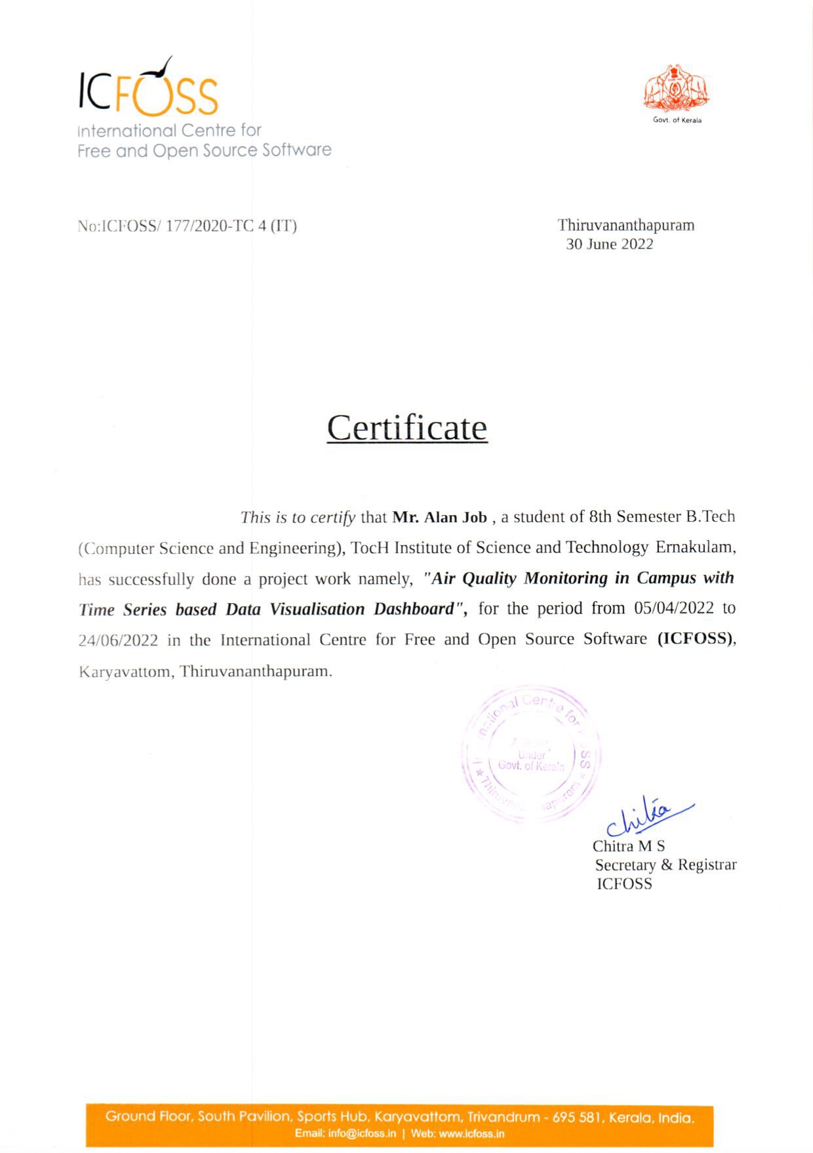

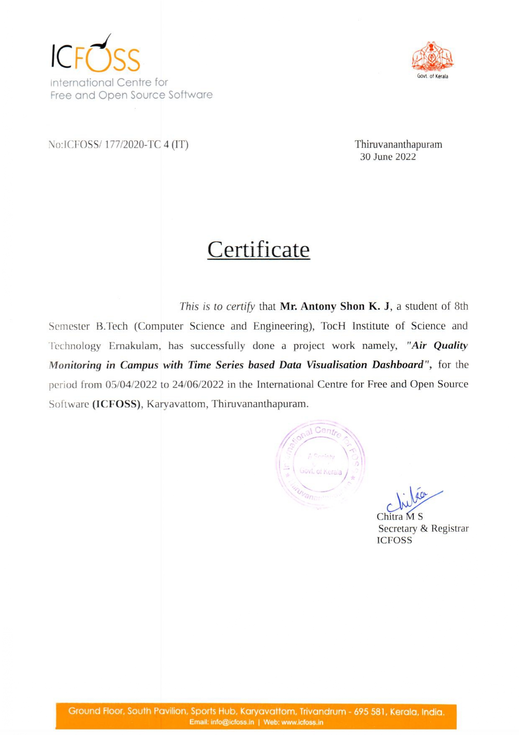

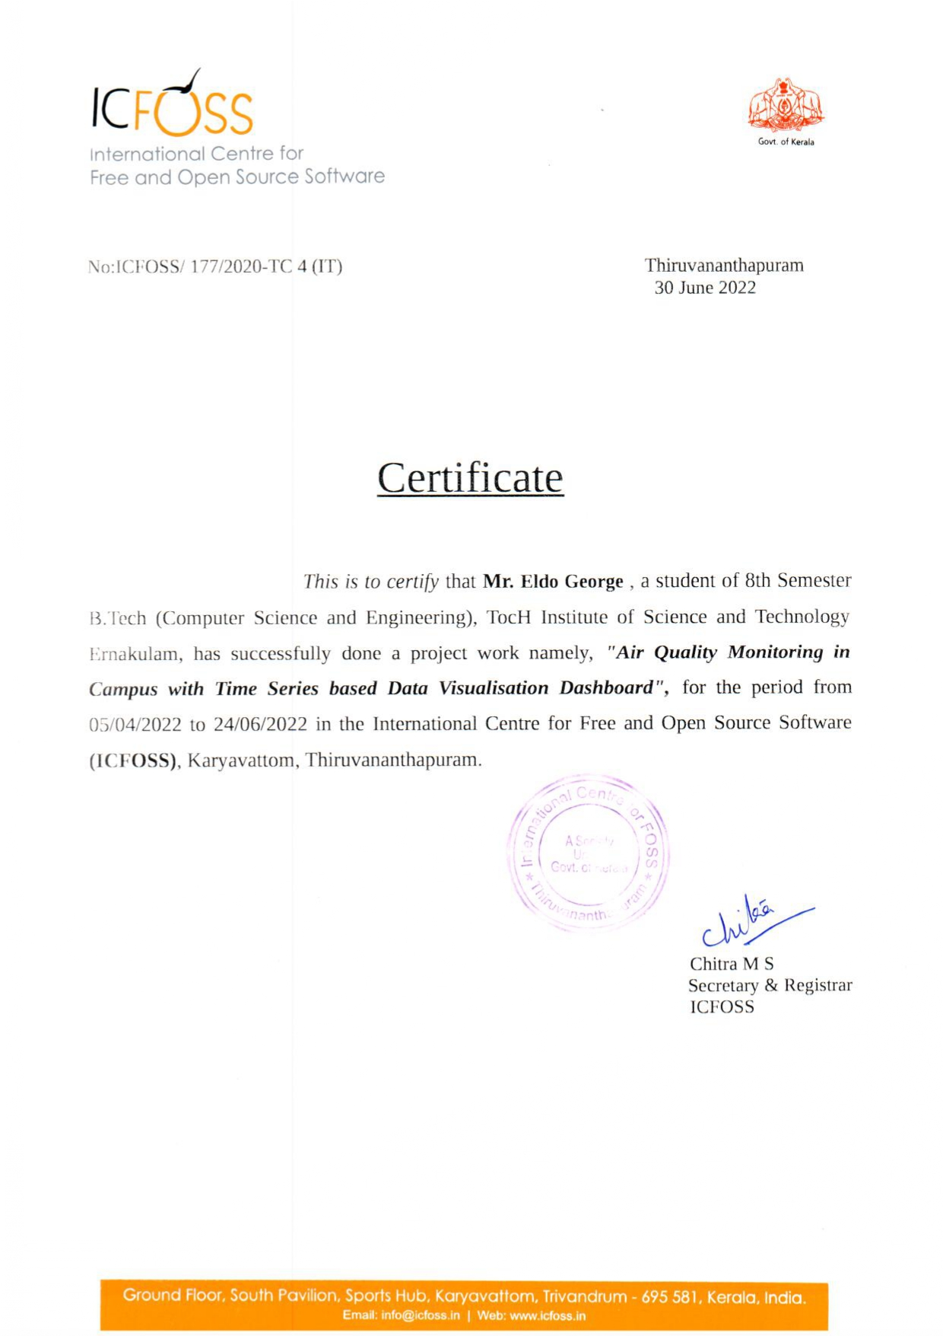

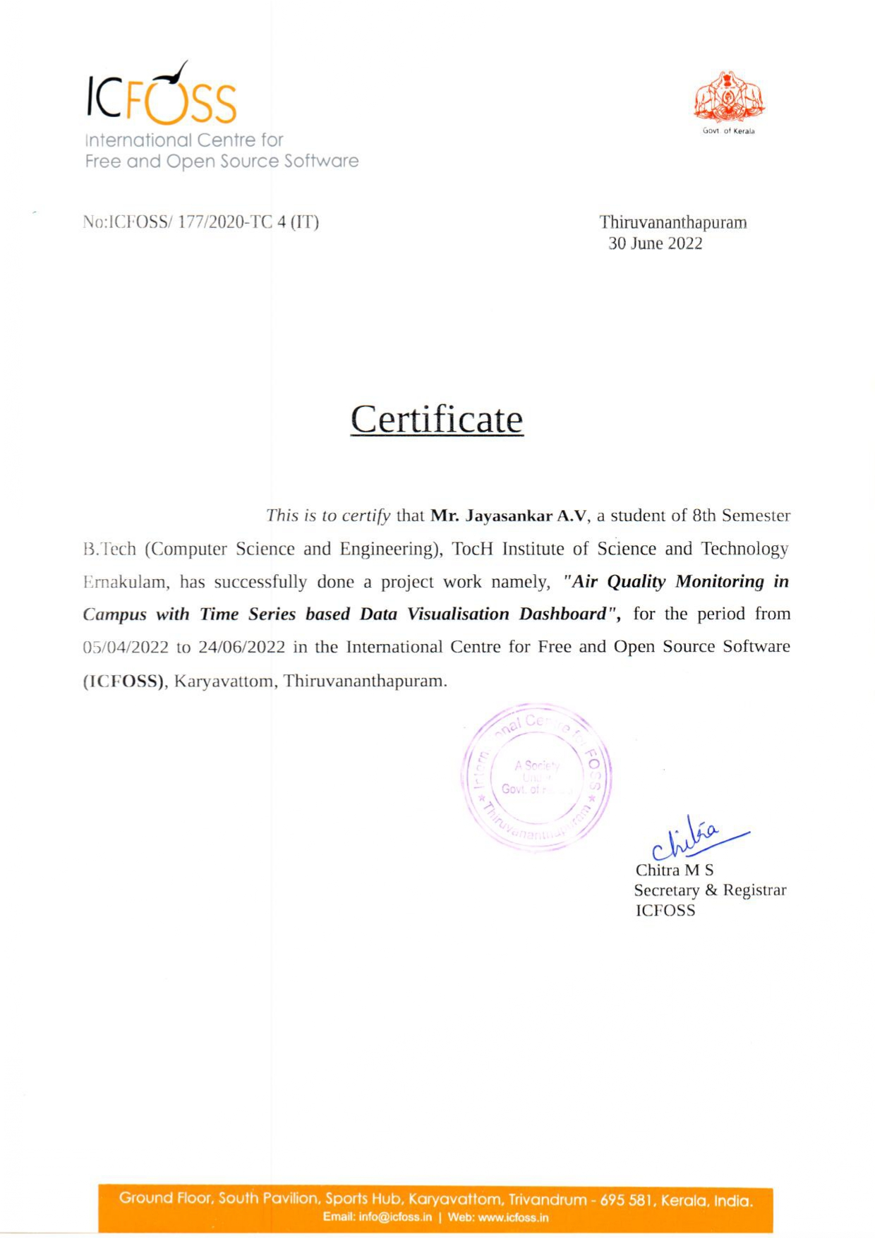

**ACKNOWLEDGEMENT**

It is our proud privilege and duty to acknowledge the kind of help and guidance received from several people in preparation of this report. It would not have been possible to prepare this report in this form without their valuable help, cooperation, and guidance. First and foremost, we wish to record our sincere gratitude to **Management of this college** and to our beloved **Principal, Prof. (Dr.) Preethi Thekkath,** Principal, Toc-H Institute of Science and Technology, Arakkunnam, for her constant support and encouragement in preparation of this report and for making available library and laboratory facilities needed to prepare this report. Our sincere thanks to **Assoc. Prof. (Dr.) Sreela Sreedhar**, Head of the Department of Computer Science & Engineering, for her valuable suggestions and guidance throughout the period of this report. Our sincere thanks to project coordinators **Asst. Prof. Elsaba Jacob** and **Asst. Prof. Abin Oommen Philip** for having supported the work related to our project. Our sincere thanks to project guide **Asst. Prof. Anuraj C.K** for his valuable suggestions and guidance. Our sincere thanks to external project guide **Mr. Arun Chandran** for his valuable suggestions and guidance. We would also like to thank **ICFOSS organization** for providing us with the needful resources. Their contributions and support in preparing this report are greatly acknowledged. We wish to thank our parents for financing our studies in this college as well as for constantly encouraging us to learn engineering. Their personal sacrifice in providing this opportunity to learn engineering is gratefully acknowledged.